BOE Assessment:

- Grouping the dataframes:

Assessment excel file include two sheets. First, we join two dataframe to work with exploratory analysis and preprocessing.

- Checking multicollinearity:

For checking if there is any significant deviation over year to year, we first check feature correlation. Since most of the metrics are correlated to each other, identifying deviation over one metrics is enough to remove them from the dataframe.

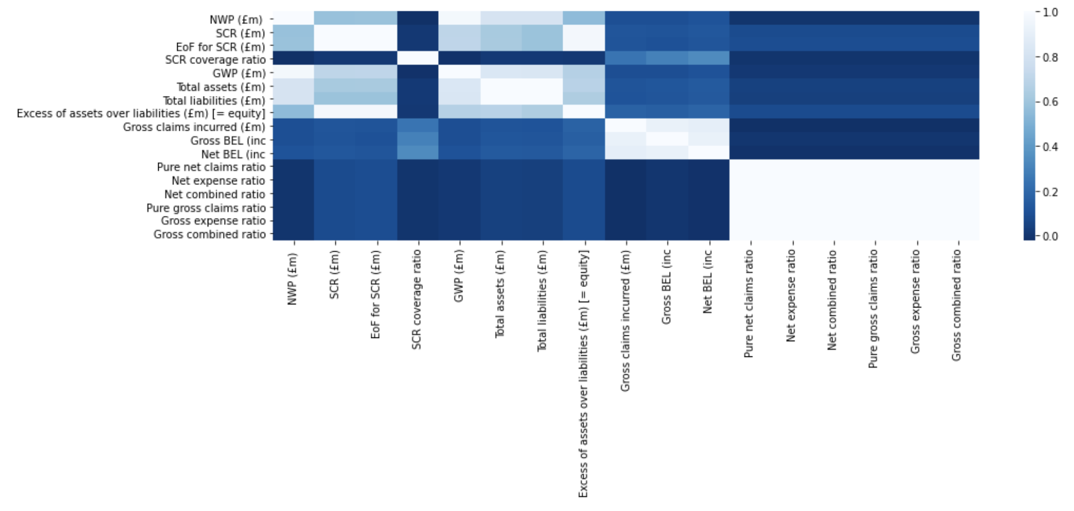
- Identifying Significant Deviation:

The firm data at single reporting period deviate significantly if it is not within 2 standard deviation from the mean.

- Distribution check

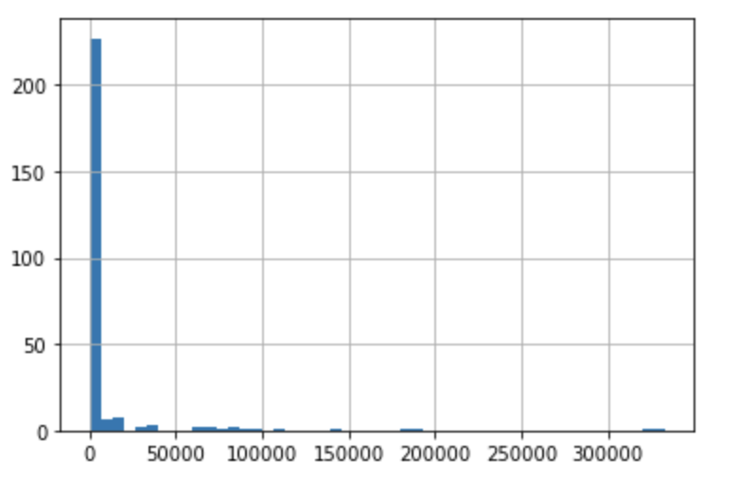
Assuming firms with zero assets is not active or there is error in reporting, we remove this firms from the dataframe, Also from the histogram above, most of the firms are small so we only focus on firms whose assets are more than 500 million euros.

- Removing Outliers or error in reporting

Now, We have remove significantly deviated rows or rows which having zero values. We take the average of metrics over the year and check outliers using Whiskers plot

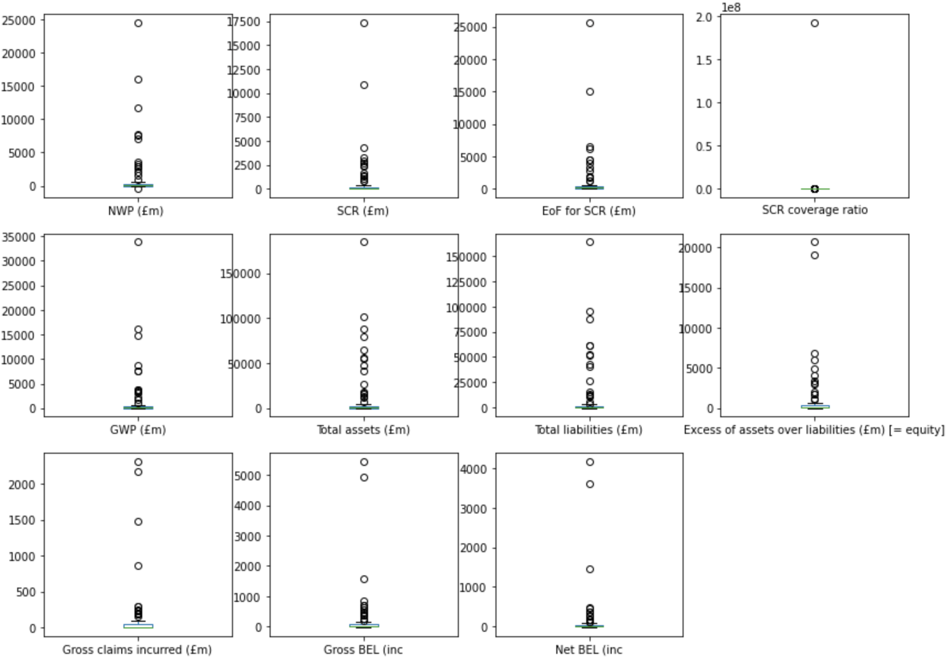

As We can see there are many outliers within the dataframe. Removing outliers from three metrics would solve this issue. Here, We remove the outliers using IQR method. We calculate the upper and lower bound and compare it with the values.

- Filtering out Firms based on their performance.
We select the firms who are meeting the prudential requirements, are in profits and with less risk to the insurer.
['SCR coverage ratio'] > 1
['Net combined ratio'] < 1
["NWP (£m) "]/["GWP (£m)"] < 1

- Bucketing Firms based on their assets value:
We Identify Firms with less than 500 million euros assets as medium and Large if its more than that.

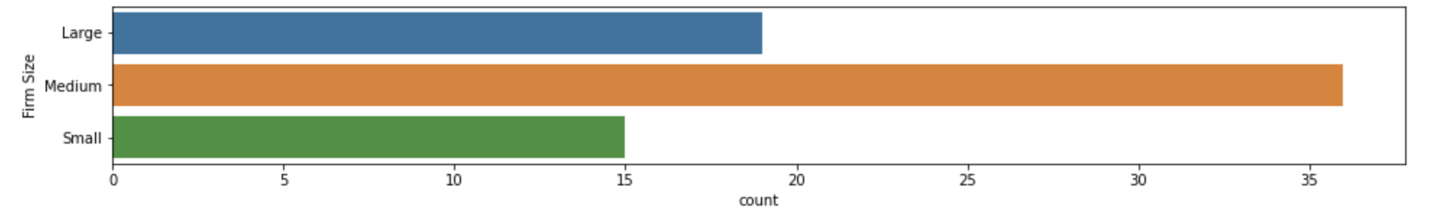

- Firms allocation:
Since bigger Firms need more attention. We Identify and sorted the Firms based on their firms size. We can allocate the resources while focusing on these Firms.
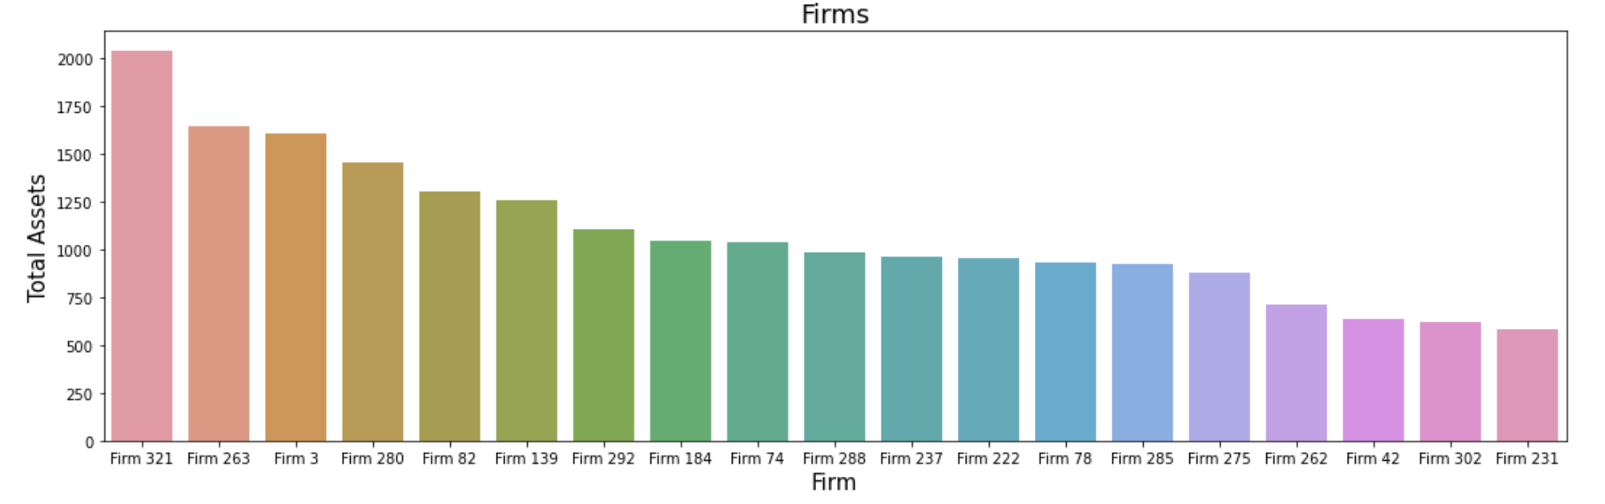

Annex : Clustering of Identified Firms

First We preprocess the data for Clustering:
- Transforming All the Numerical features into standardize form
- Encoding all the Categorical features.
- Building Pipeline to do the automate preprocessing
Deciding the no of Cluster using Elbow method:
Here No of cluster we consider is 4 and then fit the model using K mean clustering. Then we allocate each Firms with these cluster so we can get more information based on the cluster characteristics.

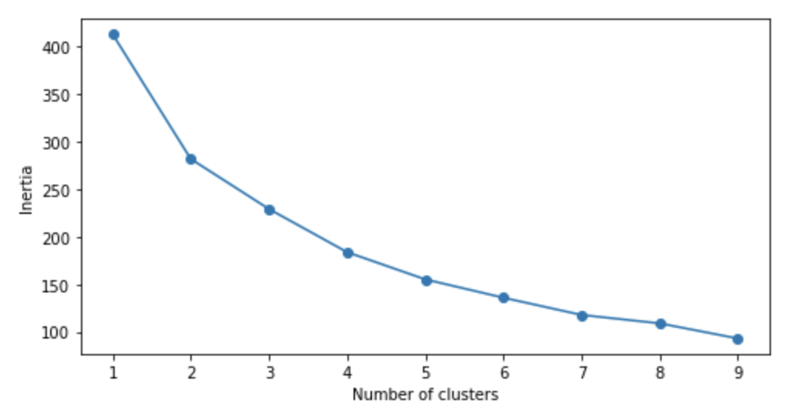
Visualizing Cluster:

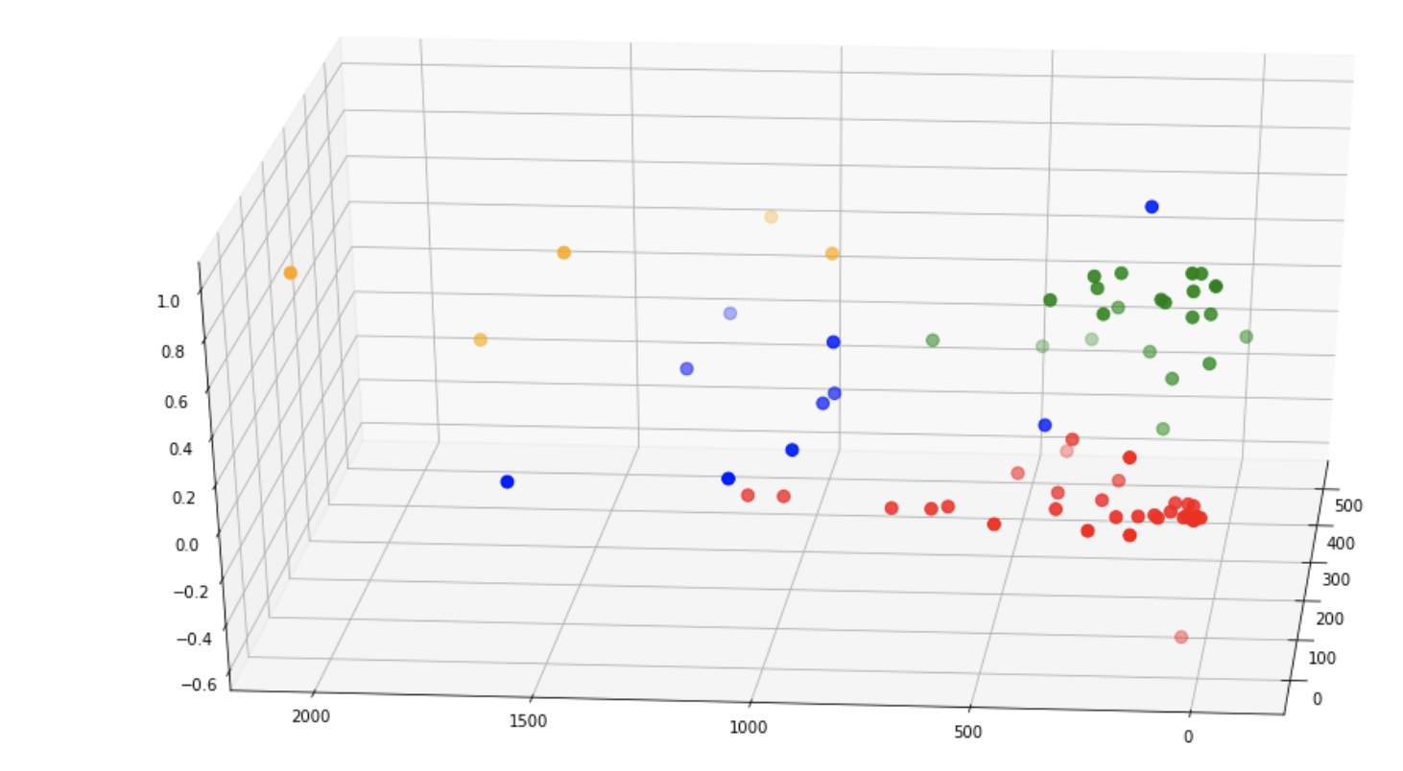
We Compare Clusters based on Firm Risk, Firm Size and profitability.

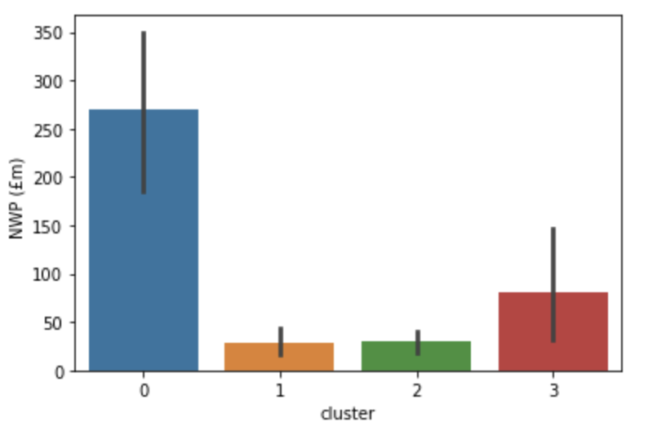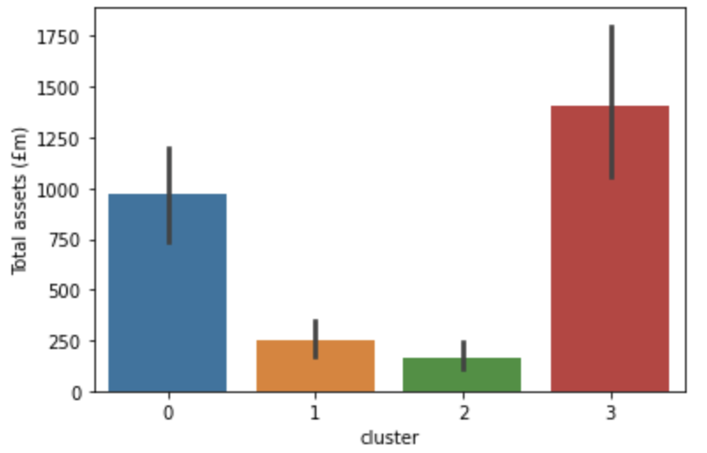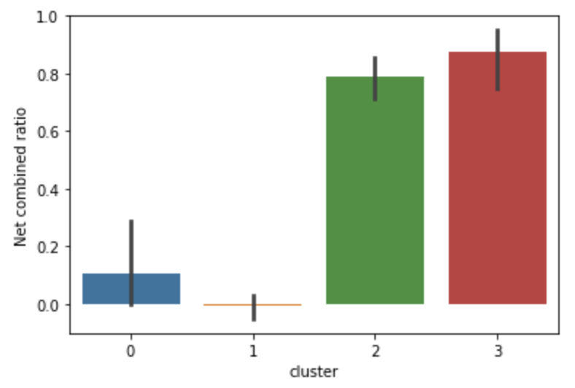
By analyzing above figures, we can priorities the resource allocation to cluster 3, 0 and 2 respectively.

